**Task1**

**Project Title: Academic Management System-**

**TASK 1: 1a)**

CREATE TABLE StudentInfo (

STU_ID INT PRIMARY KEY,

STU_NAME VARCHAR(50),

DOB DATE,

PHONE_NO VARCHAR(15),

EMAIL_ID VARCHAR(50),

ADDRESS VARCHAR(150)

);

**TASK 1: 1b)**

CREATE TABLE CoursesInfo (

COURSE_ID INT PRIMARY KEY,

COURSE_NAME VARCHAR(50),

COURSE_INSTRUCTOR VARCHAR(50)

);

**TASK 1: 1c)**

CREATE TABLE EnrollmentInfo (

ENROLLMENT_ID INT PRIMARY KEY,

STU_ID INT,

COURSE_ID INT,

ENROLL_STATUS VARCHAR(20),

FOREIGN KEY (STU_ID) REFERENCES StudentInfo(STU_ID),

FOREIGN KEY (COURSE_ID) REFERENCES CoursesInfo(COURSE_ID)

);

**TASK 1: 2)**

INSERT INTO StudentInfo (STU_ID, STU_NAME, DOB, PHONE_NO, EMAIL_ID, ADDRESS) VALUES

(1, 'Mangesh Raghuvan', '1994-05-16', '123', 'mangeshraghuvan@gmail.com', '123 Anand nagar Pune'),

(2, 'Rohan Raghuvan', '1994-08-01', '456', 'rohanraghuvan@gmail.com', '456 Anand nagar Pune'),

(3, 'Chetan Supe', '1995-04-01', '789', 'chetansupe@gmail.com', '789 Dange Chowk Pune'),

(4, 'Sai Kumar', '1995-05-20', '147', 'saikumar@gmail.com', '147 Main street Pune');

INSERT INTO CoursesInfo (COURSE_ID, COURSE_NAME, COURSE_INSTRUCTOR) VALUES

(1, 'Physics', 'Malwadkar'),

(2, 'Chemistry', 'Khandekar'),

(3, 'Maths', 'Kanjalkar'),

(4, 'Biology', 'Agashe');

INSERT INTO EnrollmentInfo (ENROLLMENT_ID, STU_ID, COURSE_ID, ENROLL_STATUS) VALUES

(1, 1, 1, 'Enrolled'),

(2, 2, 2, 'Enrolled'),

(3, 3, 3, 'Not Enrolled'),

(4, 4, 4, 'Not Enrolled');

**TASK 1: 3a)**

SELECT STU_NAME, PHONE_NO, EMAIL_ID, ENROLL_STATUS

FROM StudentInfo

JOIN EnrollmentInfo ON StudentInfo.STU_ID = EnrollmentInfo.STU_ID;

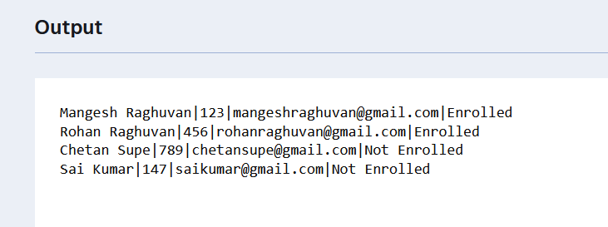

**TASK 1: 3b)**

SELECT COURSE_NAME

FROM CoursesInfo

JOIN EnrollmentInfo ON CoursesInfo.COURSE_ID = EnrollmentInfo.COURSE_ID

WHERE STU_ID = 1;

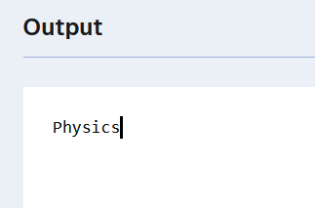

**TASK 1: 3c)**

SELECT COURSE_NAME, COURSE_INSTRUCTOR

FROM CoursesInfo;

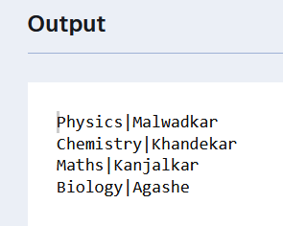

**TASK 1: 3d)**

SELECT COURSE_ID, COURSE_NAME, COURSE_INSTRUCTOR

FROM CoursesInfo

Where COURSE_NAME = 'Maths';

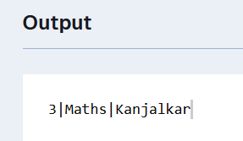

**TASK 1: 3e)**

SELECT COURSE_ID, COURSE_NAME, COURSE_INSTRUCTOR

FROM CoursesInfo

Where COURSE_NAME IN ('Maths', 'Physics', 'Biology');

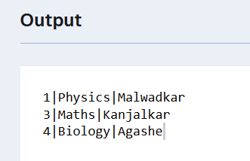

**TASK 1: 4a)**

SELECT COURSE_NAME, COUNT(ENROLLMENT_ID) AS NUMBER_OF_STUDENTS

FROM CoursesInfo

JOIN EnrollmentInfo ON CoursesInfo.COURSE_ID = EnrollmentInfo.COURSE_ID

WHERE ENROLL_STATUS = 'Enrolled'

GROUP BY COURSE_NAME;

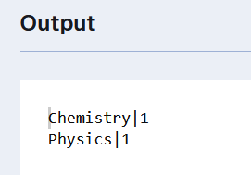

**TASK 1: 4b)**

SELECT StudentInfo.STU_NAME, CoursesInfo.COURSE_NAME

FROM StudentInfo

JOIN EnrollmentInfo ON StudentInfo.STU_ID = EnrollmentInfo.STU_ID

JOIN CoursesInfo ON EnrollmentInfo.COURSE_ID = CoursesInfo.COURSE_ID

WHERE CoursesInfo.COURSE_ID = 1;

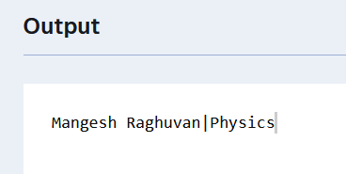

**TASK 1: 4c)**

SELECT COURSE_INSTRUCTOR, COUNT(ENROLLMENT_ID) AS Count_Of_Enrolled_Students

FROM CoursesInfo

JOIN EnrollmentInfo ON CoursesInfo.COURSE_ID = EnrollmentInfo.COURSE_ID

WHERE ENROLL_STATUS = 'Enrolled'

GROUP BY COURSE_INSTRUCTOR;

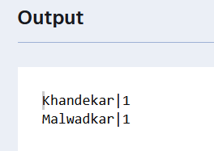

**TASK 1: 4d)**

SELECT StudentInfo.STU_NAME, CoursesInfo.COURSE_NAME

FROM StudentInfo

JOIN EnrollmentInfo ON StudentInfo.STU_ID = EnrollmentInfo.STU_ID

JOIN CoursesInfo ON EnrollmentInfo.COURSE_ID = CoursesInfo.COURSE_ID

WHERE CoursesInfo.COURSE_ID IN (1,2)

GROUP BY StudentInfo.STU_ID, StudentInfo.STU_NAME

HAVING COUNT(DISTINCT EnrollmentInfo.COURSE_ID) > 1;

**TASK 1: 4e)**

SELECT CoursesInfo.COURSE_ID, CoursesInfo.COURSE_NAME, COUNT(EnrollmentInfo.STU_ID) AS Enrolled_Students

FROM CoursesInfo

JOIN EnrollmentInfo ON CoursesInfo.COURSE_ID = EnrollmentInfo.COURSE_ID

GROUP BY CoursesInfo.COURSE_ID, CoursesInfo.COURSE_NAME

ORDER BY Enrolled_Students DESC;

